Genocide Awareness and Prevention Month Student Contest

Name:
Grade:
Email address:
School:
Social Studies/Art/English teacher:
Project Title:
Brief Description of Project (4 or 5 sentences):

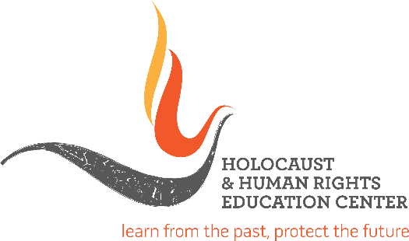

Holocaust & Human Rights Education Center
4 West Red Oak Lane Suite 204
White Plains, NY 10604
www.hhrecny.org

