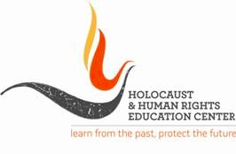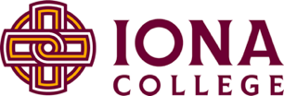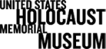

Kristallnacht Commemoration
Reconsidering the Catholic Church and the Holocaust
Virtual Film Screening and Live Discussion
Please note: This event will be held on Tuesday, November 10th, 2020 at 7:30 pm EST. A link to the film will be sent to registered guests on Friday, November 6th. The film will be available for viewing until Monday, November 9th.
Holy Silence is a new thought-provoking documentary that examines the individuals in the United States and across Europe who played a crucial role in shaping the Vatican’s response to the rising Nazi threat across Europe.
As the Nazi Party’s power and antisemitism spread across Europe in the 1930s-40s, how did one of the world’s most influential institutions—the Catholic Church—address and confront the Nazi regime and its laws, particularly the persecution of Jews? Furthermore, how did the Catholic Church's response influence its followers in Nazi-occupied Europe?

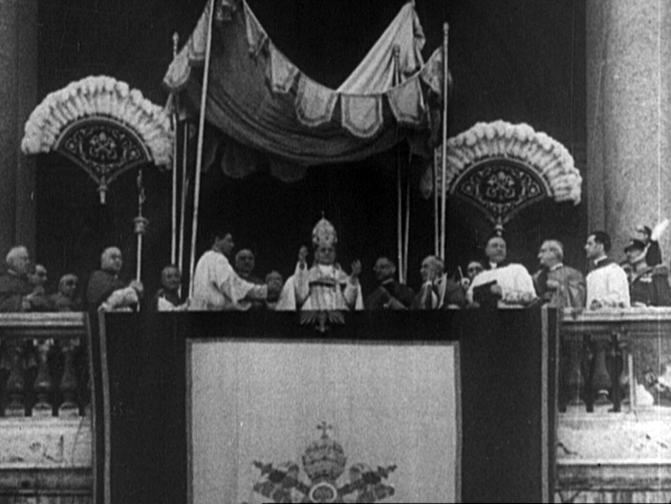
Please join us for a LIVE virtual discussion with the film’s director, Steven Pressman, Dr. Adam Gregerman of Saint Joseph’s University, Dr. Kevin Spicer of Stonehill College, and Dr. Suzanne Brown-Fleming of USHMM. Dr. Elena Procario-Foley of Iona College will moderate the conversation.

Film still from a 1939 Universal Newsreel showing Pope Pius XI on the balcony at the Basilica of Saint John Lateran. Rome, Italy. Accessed at US Holocaust Memorial Museum, courtesy of National Archives & Records Administration.

Panel discussion: November 10th, 2020 | 7:30 PM
Via Zoom
You must register for the event to receive a link to the film and panel discussion.

